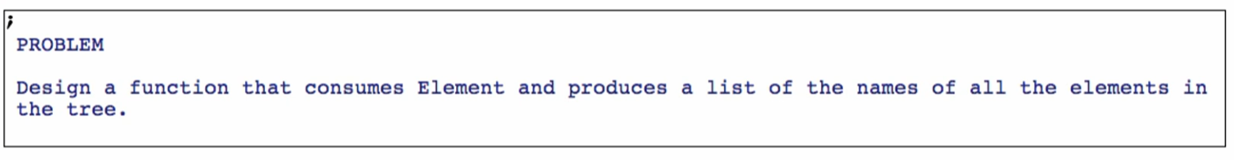

Function Definition

**Signature:**

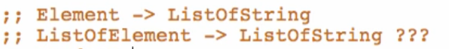

**Purpose:**



**Stubs:**

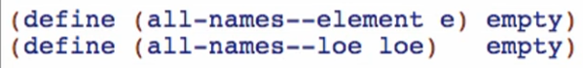

**Examples:**

Base case:

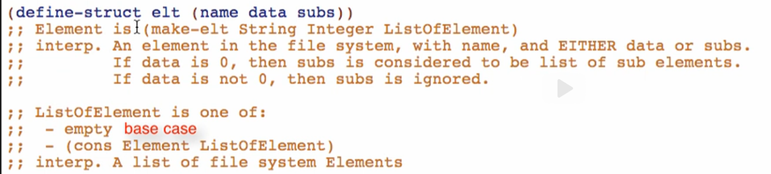

* ListOfElement only! Since we cannot see anything that will be stopping the recursion in the Element type definition
* Unlike earlier, we have a base case for Element because we have “if data is not 0, then subs is ignored” statement



Other cases:

For all-names—element



For all-names—loe



**Template**

Rename function, natural recursions, and mutual recursions

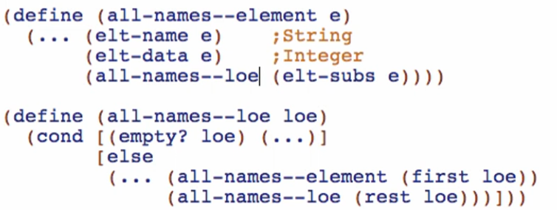

**Code Body**

Through the guide of examples

all-names—loe base case:

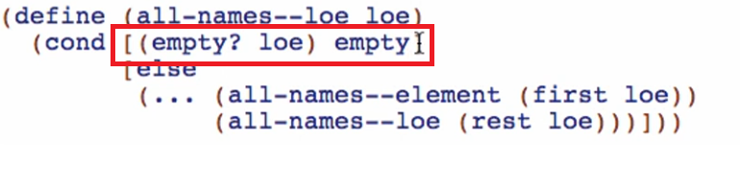

all-names—element other cases:

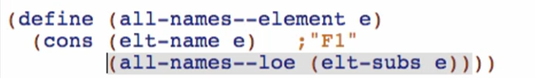

this example is suggesting ->



Try using cons for adding a “first element” instead of a using list. Especially for single data definitions. Only use list for ListOf data

all-names--loe other cases:

